The same conventions that govern HTTP client caching caching also govern HTTP network caching; in that the majority of it is operated through the same HTTP headers like Cache-Control and Etag.
Network caching is a really powerful but often overlooked component in a robust API-centric architecture. Whilst client caching focuses on local caches on each device that is making calls, network caching focuses on sharing responses to requests that pass through the network, which could be potentially made by different clients.
This has the benefit of taking traffic off of application servers, meaning some traffic spikes can be smoothed out whe n clients are request similar data. It also provides similar benefits to caching CSS/JS/images on “the edge”.
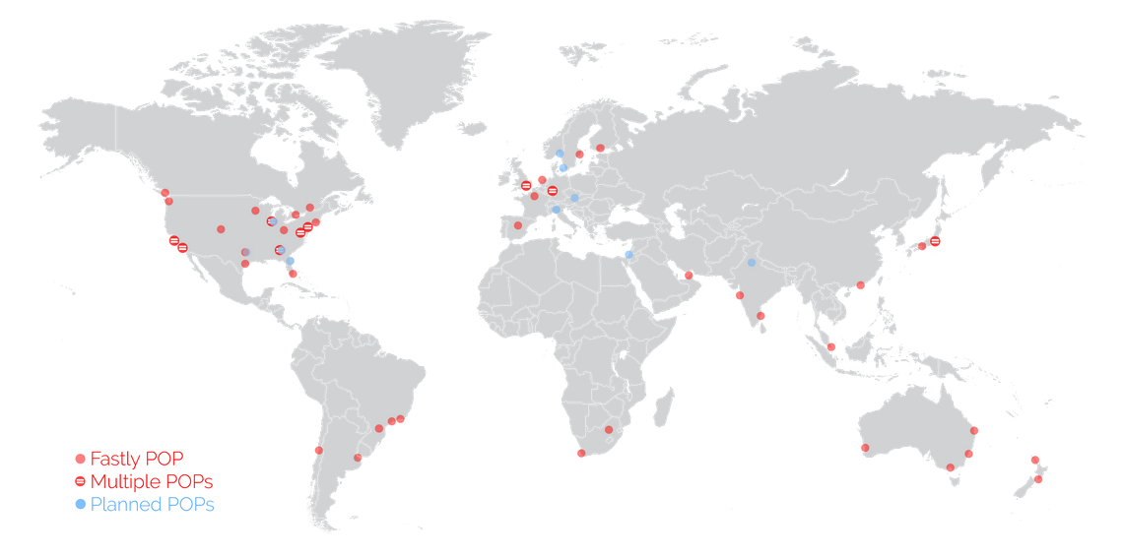
CDNs cache assets on servers physically spread around the world, meaning the assets spend less time traveling over the wire, and that means quicker downloads times for the end users requesting them. API responses can be cached in exactly the same way.
Network caching and client caching can be used together in combination, following the same set of rules, which helps to avoid complex invalidation logic. Thanks to client caching you can skip making request sometimes, then other times you grab data from somewhere physically closer to you than the application server may be. On top of the geo benefit that network cache response is coming straight from memory, instead of waiting for some poorly optimised API written in a dynamic language hastily put together by developers focusing on business goals and maybe not writing the very most performant code possible.
The basic idea looks a little like this:
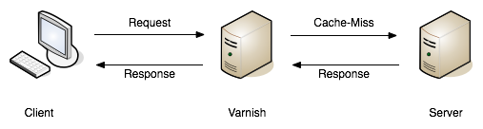
A request being returned early by a cache server. — book.varnish-software.com
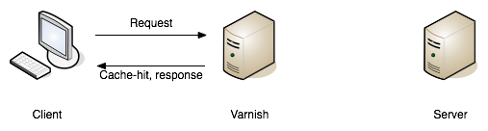
A request failing to find a match (a.k.a cache miss), and being passed on to the API server to fulfill. — book.varnish-software.com
Varnish and Squid are two common tools, and Fastly is a hosted version of Varnish. Hopefully the API developers will mention they use a network cache in their documentation somewhere, but if they do not there are common signs to look out for. Most systems will add some headers, like X-Cache, X-Cache-Hit, and there is also X-Served-By which in the case of Fastly will let you know the names of some cache nodes that served it up.
The HTTP-based cache tools can leverage HTTP headers like Etag, Vary, Cache-Control to handle cache validation, and know all the rules of HTTP, meaning this application caching can essentially be thrown in and function with very little effort from the API developers. Clients will get a speed boost without even having to implement their own client caching, even though they still could, and still should, as requesting data over the wire from the cache server is still slower than not requesting data.
An interesting thing about these HTTP conventions is that they were designed to work in a lot of situations that you probably never considered. I was blown away to hear of a use case, where HTTP cache proxies were installed in towns around Africa, to provide cached responses for websites that either didn't already network cache their responses, or did but didn't have any cache servers anywhere near that town. It meant that everyone saves a bunch of money on their data plans and the internet still works as expected.
The same logic that applies to websites also applies to data. If you are talking to a third-party API which has cache control headers but they didn't bother setting up network caching, you can set that up for them with these tools.

Max-Age Network Caching
The easiest type of network caching to understand is max age based stuff. If the API shoved a max-age=60 in there, the cache server will simply return that value if the request is within 60 seconds of a previous matching request. Theoretically the data cloud have changed, but the API is declaring that using 60 second old data is good enough.
A common misconception abut network caches is that they’ll always returned cached data and clients have no say in the matter. In the client caching section we talked about choosing when to skip the local cache — for things like hard refresh, or for whatever other reason the freshest data is required - and its exactly the same with network caching. The Cache-Control header can be used to bypass the cached version, and hit the application server to fetch the freshest data.
Something I find to be very cool, and exceptionally handy, is that API developers can set specific instructions for a network cache on top of the usual rules. If a API developer sets Cache-Control: max-age=30 then sure, clients and the network will both keep that thing around for 30 seconds, but if they set Cache-Control: max-age=30,s-maxage=86400 then its going to keep that thing around on the cache server for a whole day, but the client cache will only last for 30 seconds. This allows the developers to set up their own edge cache purging process, updating the cache server proactively if things change, and it still keeps the client applicatiton performant by skipping repeat requests in a 30 second window. Then when the thing is past thirty seconds its off to the network cache, which is hopefully physically closer!

Conditional Validation In Network Caching
Ok so time based network caching might make enough sense, but what about conditional validation with things like Etag?
When you make a conditional request to a cache server, you are always going to hit the application server. This confused me so much when I first started digging into this. What on earth is the point of that?
Assuming there was a max age on there, the response was considered “fresh” for some time, then the client cache had to validate to see if anything has changed. The conditional check will pass straight through the network cache, and the same conditional check is made to the application server. If the etag does not match, then it is considered “stale”, and the full response will be returned by the API: a 200 OK with a whole bunch of JSON to give the network cache, and the client cache, a full new response to hold onto. If things changed, the 304 Not Modified is returned by the application and passed through the network cache to let the client cache know its got the latest thing.
Network caching is not wildly useful for conditional validation, it is mainly there for max age based stuff, but if the API developers are leveraging both then it still has value.

GraphQL
Due to the way GraphQL generally operates POSTing against a single endpoint, HTTP is demoted to the role of a dumb tunnel, making network caching tools like Varnish, Squid, Fastly, etc. almost entirely useless. If the API developers were kind enough to also allow queries to be made over GET then you can switch to using that, and technically network caching will work at a very basic level, but the chance of a cache hit is minimal, as the entire query has to match perfectly (asking for foo and bar, not bar and foo). It's not even guaranteed that GET is supported for a given API.
With standard HTTP-based network caching essentially removed from the equation, some third-party solutions have started popping up. One of these is FastQL, a name inspired by Fast.ly but built specifically for GraphQL. It might not be easily to tell if the API developers have that enabled.
If they have not enabled a network cache you are out of option. Unlik HTTP-based caching solutions, client developers are not be able to run their own network cache that the API development team is unaware of, as it relies on purge requests being made to it to remove outdated information and replace it with newer information. Basically that means if you set up your own network cache, you would have to find some way to subscribe to data changes on their end, and repopulate the data on the cache server maybe using some sort of scheduled job, all of which sounds like quite the faff.

